**Database Design Project**

**Alexander Graham**

**R00142233**

**SDH-2A**

# Project Description

* This application system is built for the use of entering new ships into a database and learning about pre-existing ships, through entering information like i.e What nation it is from?, What type of main gun does it have and the rank of the captain.

# Design Of The Database

* The progression of the table design will be shown on a blue sheet of paper attached to this document.

# Time Management/ Technical Issues and Solutions

## From week of March 25th – 30th April.

Any information and help or inspiration I used and referenced will be at the end of this document.

## Week of March 25th – 31st

* I first started off by drawing out potential tables that could be used to create my database. This ended up taking about a week to do, as the data was based off a game called World of Warships and this had many potential data that could be used as a table. These potential table designs will be attached on a blue page along with the finished table design.
* A big probably I encountered when making these tables, is that I found myself having repeating data within a couple of my tables.
* Below are what my first idea of what I thought my tables should be like:

Tables

Table to link nations to ships

Nation

(typeOfShips)

CV

(amountOfPlanes)

BB

(typeOfGun)

(armourValue)

Cruiser

(typeOfGun)

(torpedo)

DD

(torpedoRange)

(detectablity)

* The problem using these is that my data be repetitive in each table as most ships have the same characteristics. This in turn would cause a lot of repeating data.

## Week of April 1st – 7th

* I started off my week by setting up my tables in mySQL workbench, using create statements. I gained the information to be put into the tables from the World of Warships Wiki.
* During the creation of some of these tables I had to figure out a good way to link each table together in some way so that if an inner join was used across multiple tables it would work.
* A problem I encountered doing this in mySQL Workbench was finding the best primary key to use as a good foreign key in another table. Also unfortunately towards the end of this week and about half way into next I fell ill and was bed ridden for quite some time.

## Week of April 8th – 14th

* As I was still ill for half of the week, I was still trying and testing for a good primary key to be used as a for foreign key, once I managed to pick good foreign keys for each of my tables, I then focused on forcing the user to not leave some fields empty i.e a foreign key field.

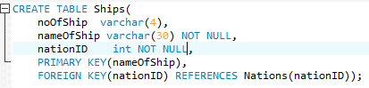

* I also for a brief period during the week looked into possible GUI designs for the interface that the user would be faced with, but did not attempt to code during this week.

## Week of April 15th – 21st

* This week I went on the hunt to find a possible GUI the could gain inspiration from to develop my own GUI for the database. I managed to find a possible GUI that I could look upon for guidance. It gave me the idea of having three buttons that I would use for INSERT, UPDATE and DELETE. Then have 3 text fields that the user would be able to input data into. Also to have a list view that would display the data the is already inside the database.

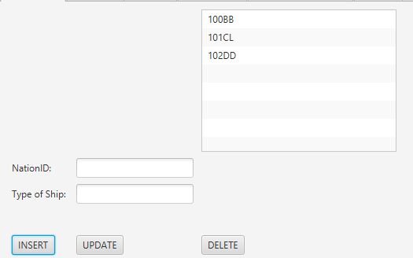

* With this idea in mind I went ahead and created each of my five tabs with this idea in mind.
* Once the GUI was in place and displaying, I then set about tackling the functionality of the buttons, the text fields and the list view.
* I first started off by trying to get a table from my, mySQL workbench database to display inside of the listview. This meant having to store the information in an array, pass it through and observerable list and set the content of the listview to the oberserverable list. Then I used a SELECT * FROM statement, selecting the table I would like to display and the columns.
* The sql statement inside the java code was able to execute as I had imported a .jar file that would connect my, mySQL workbench too my java project.

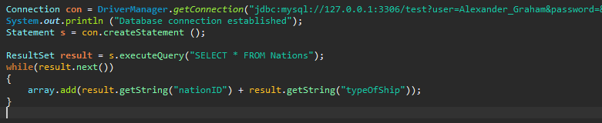

* However, using the listview meant that the data would be squished together and look untidy and if I was to revisit the project I would change the list view too a table view.
* The only main problems I encountered during the course of this was the positioning of the buttons, text fields and the list view. I was using grid panes instead of VBox and HBox which I am used to so positioning on a grind pane was a bit tricky.

## Week of April 22nd – 28th

* During the course of this week I ran into many problems. This week I aimed to be done the project but problems relating to the mySQL connector and some problems with my text fields made me run over the weekend and into Monday the following week.
* I started off by creating the functionality for my insert button, where a user is able to enter 2,3 or 4 pieces of information they’d like into the table. Once I developed this ActionEvent, including and sql statement, I ran the program to test whether I could enter the data into the table (it worked). Then went about creating the update and delete button in the same way but having a different sql statement inside.
* When I came back to my laptop the following day, my laptop needed an update due to the mysql connector, once I was able to get in and run my code an error generated “The server time zone value 'GMT Summer Time' is unrecognized or represents more than one time zone. You must configure either the server or JDBC driver (via the serverTimezone configuration property) to use a more specifc time zone value if you want to utilize time zone support.”
* For the longest time I could not figure out how to change the server time zone of, what I thought to be the problem, MySQL Workbench. I also tried to recreating my java project and connecting it to a different database on MySQL Workbench (this did not work).
* After spending almost a day I enlisted in the help of the internet and searched up my problem. It lead me to StackOverFlow where they said that in my connection to the database to include additional code after my password.

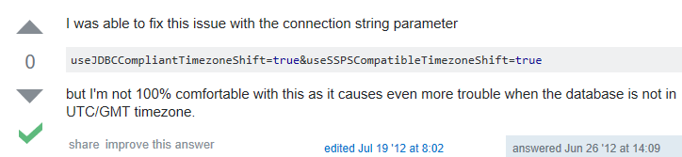

* This sadly still had no effect on my project. Then a sudden realisation hit when I was entering my database in MySQL…

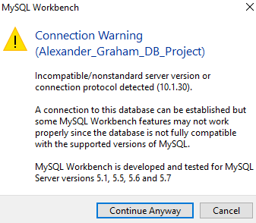

* “MySQL Workbench is developed and tested for MySQL Server versions 5.1, 5.5, 5.6 and 5.7”
* This lead me to believe that the connector I was using to link java and Workbench was still a work-in-progress connector. So when the connector updated it didn’t change the time zone to match but instead created another time zone, so Workbench and java both thought that this could not be right and through the error.
* How I solved this then was I downloaded an older but stable version of the connector from MySQL Connector releases, picked the 5.1.45 and included that one in my project instead of the 8.0.11 version.
* When I included this in my project along with the additional code suggested my project ran at last.
* One more problem crept up though when I was entering data into my text fields, I had somehow managed to mix my text fields up so when, I would enter data into one text field that was meant to be for a name, in turn I had got the order of the text fields wrong so it would pass the name into a field that was meant for a number.
* This was an easy fix as all I had to do was read over my code where the text fields were and see what was going where and move the order to match the sql data coming in.

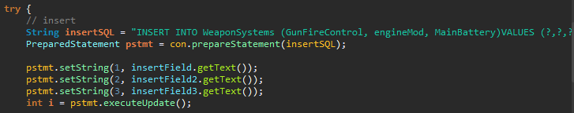

* Once I had sorted out my text field issues, I then set upon creating my three additional statements that I had to implement into the program.
* I looked at W3Wschools for both guidance and inspiration on creating statements for my tab.
* I ended up using an INNER JOIN, SELECT DISTINCT and a GROUP BY. I then ran each of these statements in MySQL Workbench before implementing them into my program, as if an error occurred I Workbench would be able to give me a detailed error.
* INNER JOIN

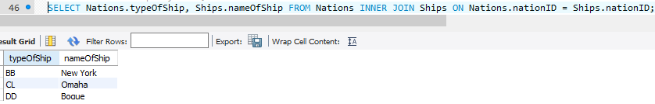

* SELECT DISTINCT

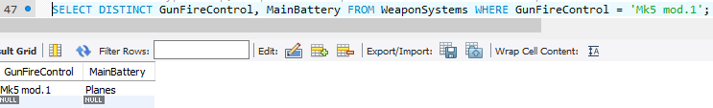

* GROUP BY

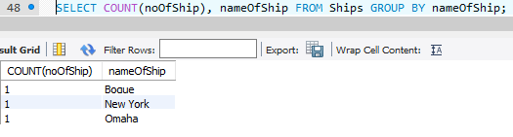

# Conclusion

* Overall doing this project I felt things went rather smoothly bar the few problems I had encounter.
* If I was to revisit this project I would instead of using a list view, use a table view instead, as it would improve the way the data is displayed to the user, making it more pleasing to the eye.
* I would also spend less time on creating the actual database itself as I feel, I spent too much time on the development of the tables and the rows going into it.

# References

* Possible UI Design: <http://1bestcsharp.blogspot.ie/2015/03/java-mysql-insert-update-delete-data-from-mysql-database-using-java.html>
* World of Warships wiki: <http://wiki.wargaming.net/en/Ship:Ships_of_U.S.A>.
* JWright GUI DEMO MASTER: <https://github.com/JaretWright/GUIDemo>
* W3Wschools: <https://www.w3schools.com/sql/>
* StackOverFlow: <https://stackoverflow.com/questions/11156745/mysql-jdbc-date-issues-with-database-server-in-different-timezone>
* MySQL Connector: <https://dev.mysql.com/downloads/connector/j/5.1.html>